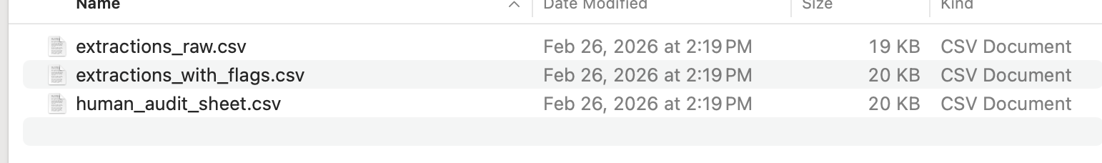

Conceptual:
Since Schema constrained the LLM to fulfilled the blank parts, working as assistance, but not automation. Even though we constrained the LLM by using this method, the results are probabilistic outputs. Using Schema is helpful in fixing the format, but do not guarantee the content accuracy. For instance, I asked the LLM to fulfill the blank part as answer who did what at what time, it can perform as a non-human behavior, such as my cat watched movies by herself, but actually it was me to watch the movie.

